Course Name:  Course Code: | Basic of Electrical Engineering Laboratory  316U06L102 | Semester: | I
Date of Performance: | / /20-- | Batch No:
Student Name: |  | Roll No:
Faculty Sign & Date: |  | Grade/Marks: | / 20

Experiment No:

Title: Superposition Theorem

Aim and Objective of the Experiment:
- To Verify Superposition Theorem.(Using VLAB)

COs to be achieved:
CO1: Analyze resistive DC networks using various network theorems.

Requirements
https://asnm-iitkgp.vlabs.ac.in/exp/verification-superposition-theorem/index.html

Theory:
If a number of voltage or current source are acting simultaneously in a linear network, the resultant current in any branch is the algebraic sum of the currents that would be produced in it, when each source acts alone replacing all other independent sources by their internal resistances.
Circuit Diagram:
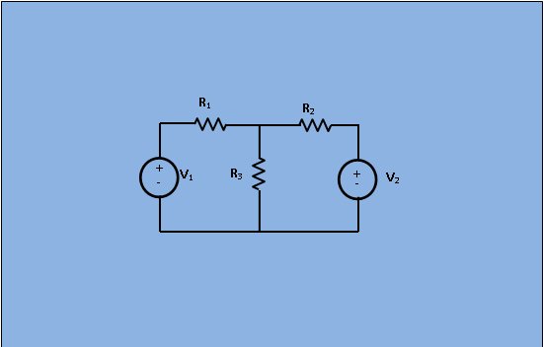
Fig.1 : Circuit for analysis of Superposition theorem
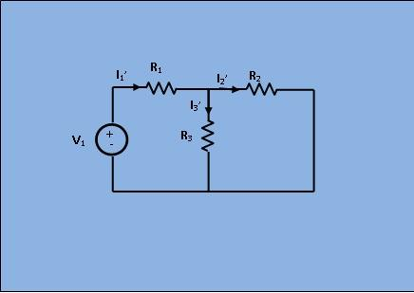
Fig.2 : Circuit with only V₂ short circuited
In given figure 1 apply superposition theorem , let us first take the sources V₁ alone at first replacing V₂ by short circuit as shown in figure 2.Here,
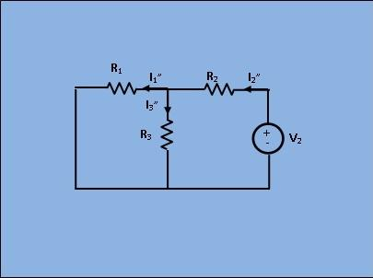
Fig.3 : Circuit with only V₁ short circuited
Next, removing V1 by short circuit, let the circuit be energized by V2 only as shown in figure 3. Then,
As per superposition theorem,

.

Superposition Theorem: (Using VLAB)
Using following link open VLAB experiment for Superposition Theorem Verification.

- Set the any 5 values of R1,R2,R3 and choose any 5 arbitrary values of V1and V2.
- Find the current values in presence of both sources.
Case 1: In presence of both the sources
- Select switch of S1 and S2 to power and Simulate the program. Observe the result from case 1 tab.

Case-2: In presence of V1 only
Apply switch S1 to power and S2 to short. Simulate the program. Read ammeter values from Case 2 tab.

Case-3: In presence of V2 only
Apply switch S1 to short and S2 to power. Simulate the program. Read ammeter values from case 3 lab.

- Update the observation table.
- For any one values of R1,R2,R3 and V1,V2,V3 –Verify theoretically.
- Attach the screenshots of the circuit, results
Screenshots of Superposition Theorem using VLAB

Observation Table:

Conclusion:

Signature of faculty in-charge with Date:

